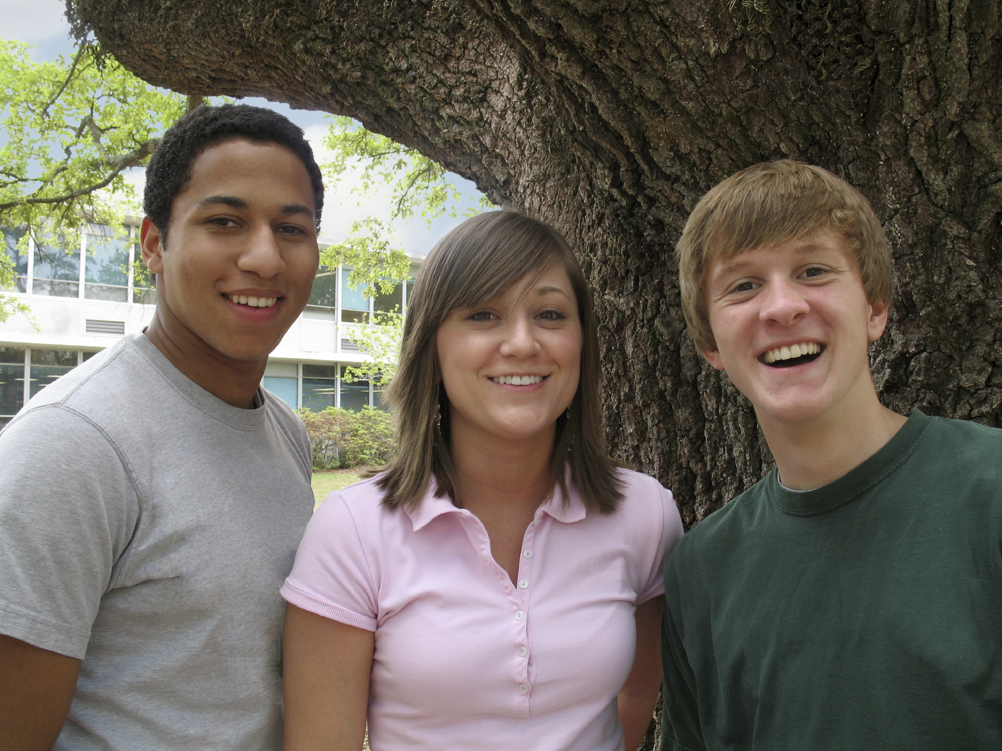

BYU AUTISMCONNECT

If you would like to learn about this research project, email [autism@byu.edu](mailto:autism@byu.edu) today.

Autism.byu.edu for information about autism research at BYU

## Ages 12 -- 17

Scouting for Friends

### Social Skills Intervention Research Study (**Participation is free**)

### Adolescents with Mild to Moderate Autism Spectrum Disorders

* Social Skills Group Instruction
* Training for the adolescent’s community group (Scouts, athletics, church groups, etc.)
* Parent groups

Randomized Control Trial for Social Skills Intervention

autism@byu.edu