The New Newsies: Uncovering the Stories Buried beneath the Golden Spike

A Hybrid Readers’ Theatre Piece

The playing space (e.g., the front of a classroom, a hallway foyer, the area below a stage) should be intimate—that is, this is not an assembly performance piece for a large audience. The cast could be costumed in solid-colored tee shirts, shorts, baseball caps (initially worn at varying angles, bills askew), and sneakers.

The brackets in the following text are to be filled in with the names of the respective student performers who will read/deliver the lines.

Note: This piece is intended to be performed with scripts in folders, but also with the use of stage pictures (i.e., arrangements of performers to emphasize the subtext and extensions of many of the lines). To help students prepare for the performance, the lines just before “their” lines could be highlighted in yellow. Their own lines could be bracketed in yellow.

The following picture could be projected, or it could simply be used to provide context for the performers as they prepare.

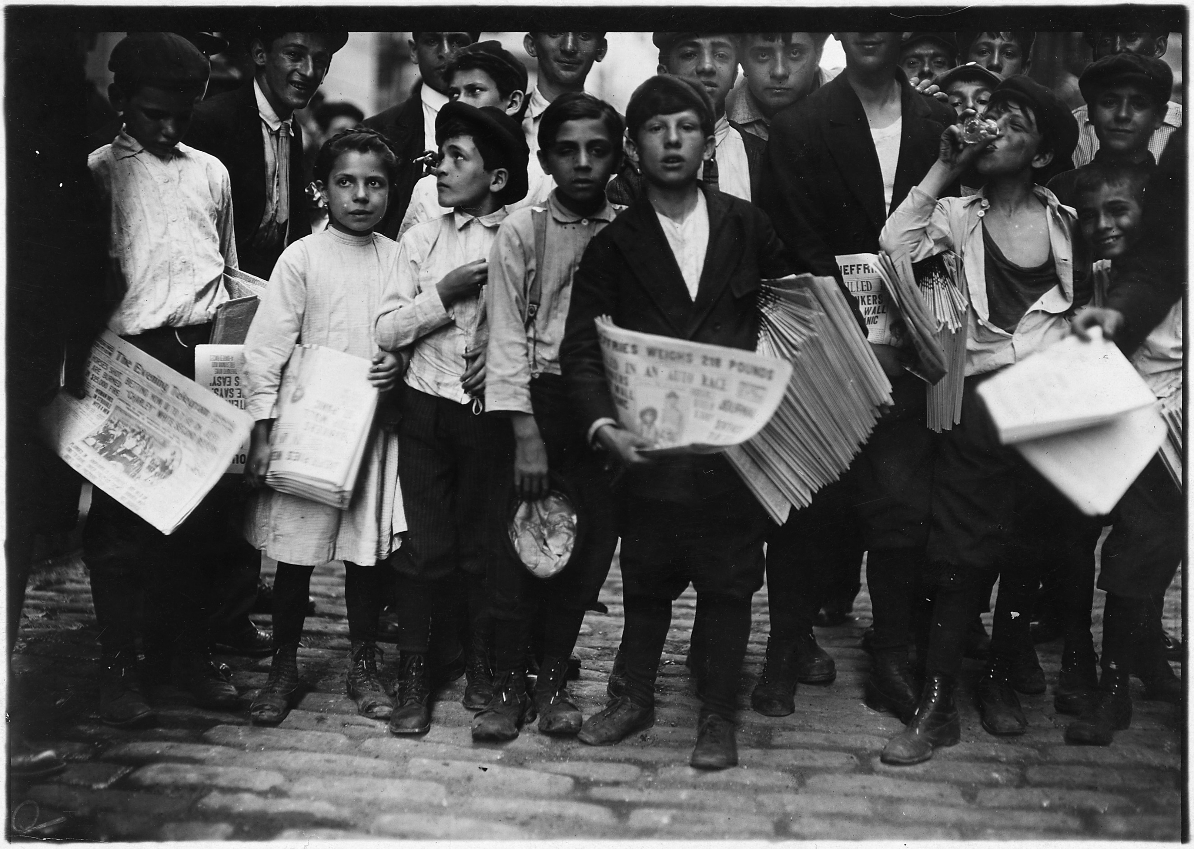
The above picture by Lewis Hine can be found at
https://commons.wikimedia.org/wiki/File:Newsboys_and_newsgirl._Getting_afternoon_papers._New_York_City._-_NARA_-_523329.jpg (public domain).

For more information to mine on the newsboys and newsgirls’ strike, visit
http://www.boweryboyshistory.com/2010/06/newsies-vs-world-newsboys-strike-of.html.

The performers enter the space in their role as newsies. A choral chant begins.

[ALL] Extra, extra, read all about it. Extra, extra, read all about it.

The chant continues until all performers are “on stage,” forming a tight stage picture that evokes “getting the afternoon papers.”

[ ] So the two-week New York City newsboys strike of 1899 wasn’t just newsboys.

[ ] Nope. There were newsgirls, too.

[ ] But certainly many more boys.

[ ] Many, many boys.

[ ] Many, many poor boys—some homeless, some not.

[ ] But many poor girls, too.

[ ] Working for newspaper barons Joseph Pulitzer and William Randolph Hearst . . .

[ ] Hardly poor . . .

[ ] Hardly homeless.

For more information on these two newspaper barons, visit https://www.pbs.org/crucible/journalism.html

[ ] Okay, okay, but we ain’t no newsboys . . .

[ ] Or newsgirls.

[ ] We’re just using our knowledge to try on their roles.

[ ] Hawkin’ newspapers.

[ ] Sellin’ the stories of the day.

[ ] Things have certainly changed in how we get our news.

[ ] From smeary printed pages hawked by newsboys . . .

[ ] And newsgirls!

[ ] To AM radio in the 1920s.

[ ] To FM radio in the 1940s.

[ ] To television in the 1950s.

[ ] To the internet as we knew it in the 1990s.

[ ] Search engines, websites, digital archives, Facebook, YouTube. . . .

A choral—

[ All ] Google . . .

[ ] A new sort of news.

[ ] But also a way to look into the past that we’ve never had.

[ ] An amazing research tool.

[ ] To find the big stories, the lesser-known stories.

[ ] The non-stories.

[ ] The backstories. . . . A way to look into the past in new ways.

[ ] For us in Utah, and across the country, this is a year that begs for a look at a lot of
stories.

[ ] The 150th anniversary of the golden spike.

[ ] Which begs for a deep look at this event through a bunch of diverse lenses, through a
host of diverse questions . . .

[ ] That we can feed into a computer’s search engine and it will reveal a list of
sources to research.

[ ] So we’re playing reporters and “newsies.”

[ ] Looking at the golden spike as if it were the center of an onion.

[ ] Peeling back the layers, each one telling its own story, a part of the whole.

[ ] How about another metaphor? Tracing threads of a richly colored tapestry from a
multitude of perspectives. . . .

A choral onomatopoeia—

[ All ] Oooohhh.

[ ] So where do we start?

[ ] What are the questions that will help us piece together the complex story of the
Transcontinental Railroad?

As the questions are raised, the performers who will read the following lines break from the clustered stage picture and move L and R to form a line across the playing space. As they move toward stage left and right, they adjust their caps so that the bills are straightened. Once the line has been established, student performers can pick up other lines without moving. The staging idea is to shift the narration SL and SR in a nonsymmetrical fashion.

The questions are to be understood as an invitation to teachers and their students to begin their research—in small groups or as a class—and to possibly create a hybrid readers’ theatre piece of their own using this script as a model.

[ ] Let’s start with the who. Who pushed for the railroad? What were the motives at play?
Who stood to gain the most in the short term? In the long term? Why was the railroad important at this particular point in American history?

[ ] How was the final route selected? What were the key issues?

[ ] Who decided which route should be followed?

[ ] What did our government—a government that was deeply engaged in the Civil War at
the start of the project—do to support the railroad?

[ ] How else was the railroad promoted?

[ ] Where would the labor to build the railroad come from? What would workers be paid?
And how would the workers be treated? During construction and after?

[ ] What was a typical day like in the lives of those impacted by the railroad? For those
building east to west and for those building west to east?

[ ] But also for those who watched and experienced the tracks going down—the farmers
and ranchers.

[ ] People’s questions . . . Understanding the roles played by powerful people, and by not-
so-powerful people.

[ ] Immigrants. Soldiers.

[ ] Mormons.

[ ] Our Natives.

[ ] But also “place” questions, like the impact on the environment—on the land, on the
animals and plants that lived on the land. . . .

[ ] You mean, like the buffalo?

[ All ] We do.

[ ] Okay, but where would the materials come from? The steel, the timber, the machinery,
the nitroglycerin?

[ ] And once it was completed, how was the railroad used?

[ ] What impact did its completion have on our country? On cities and towns along the
route?

[ ] Besides being used to transport goods and raw materials east to west and west to
east, who rode the train?

[ ] One group that was transported by train from west to east—our Native children—

[ ] Lakota, Cheyenne, Kiowa,

[ ] Pawnee, Apache, Sioux,

[ ] Ute, Shoshone, Navajo, Hopi,

[ ] And many, many children from many, many other tribes . . .

[ ] 10,000 children, from 141 tribes in all, were part of the Carlisle Schools Project.

[ ] Thus, early train travel was used to aid in the removal of Native children from their
parents and their tribes . . .

[ ] To transport them to Carlisle Schools, first in Pennsylvania, and then to other sites.

[ ] Why? What was going on here?

[ ] Indeed.

[ ] What was going on here?

[ ] Our search for stories reveals some big conflicts—between ideas and realities.

[ ] Both are important in determining what happened, why, when, where, and how.

[ ] There have been a number of celebrations of the completion of the railroad—from the
day the golden spike was driven, up to and including May of last year at Promontory Point. What do the artifacts of these celebrations—the speeches, the photographs, the news stories—tell us about ourselves?

[ ] This year is another celebration, another milestone.

[ ] The history of the Transcontinental Railroad is certainly messy. But in pulling apart the
onion . . .

[ ] By exploring the threads of this complex tapestry . . .

[ ] We may be in a better position to understand our past as we prepare for a powerfully
inclusive future.

[ ] So . . .

A choral—

[ All ] Have at it!

Curtain

