7 CHARACTERISTICS OF STRONG PHONICS INSTRUCTION
Wiley Blevins

1 Readiness Skills

Characteristics | Instructional Issues | Next Steps
Phonemic Awareness  Alphabet Recognition | ■ Focus on oral blending and oral segmentation—most closely connected to reading and writing growth   Be cautious of inappropriate pacing of lessons   Add articulation work (look and feel of sounds—mouth, lips, throat vibration) | ■ Fine-tune instruction (e.g., students say sound when writing letter during handwriting practice)   Build in daily fluency work for mastery (e.g., letter-sound cards)   Use review skills for instructional transitions   Include technology (apps and whiteboard activities)
2 Scope and Sequence

Characteristics | Instructional Issues | Next Steps
Starts with high-utility vowels and consonants  Focuses on making words as early as possible  Uses sequence that works for majority of students, but has built-in differentiation  Recognizes that not all skills are equal | ■ Need significant review and repetition cycle (4-6 weeks after initial introduction)   Increase teacher knowledge of linguistics to make more-informed instructional decisions   Match phonics to reading (e.g., when students begin to read multisyllabic words)   Create comprehensive phonics mastery assessment   Don’t overdo it   Devote more time to non-transferable or challenging sound-spellings | ■ Teach to mastery, rather than just exposure (evaluate curriculum for proper coverage of skills)   Differentiate instruction during small group AND whole group lessons   Add review and repetition cycle
3 Blending

Characteristics | Instructional Issues | Next Steps
Primary decoding strategy  Must be frequently modeled and applied  Uses strategic blending lines (including minimal contrasts) | ■ Make sure the focus is applying skills to real reading and writing—not isolated skill work   Improve teacher knowledge of research-based routines   Focus on high-utility words in lessons   Include vocabulary work   Make sure gradual-release model is used (and teacher isn't doing all the work/thinking) | ■ Add review skills to blending word lists each day   Add transition to longer words work early on   Add word pattern sorts (untimed and timed)   Include technology (apps and whiteboard activities)
4 Dictation

Characteristics | Instructional Issues | Next Steps
Connects reading to writing  Can begin as early as Kindergarten (1st level with sound-letter matches, then slowly progress to words and simple sentences) | ■ Formally teach students how to transfer reading skills to writing through guided dictation early on (connect to spelling lists)   Increase opportunities to write words   Use sentence stems to build base of useful sentences with each word | ■ Add review skills to dictation work   Add writing work to the reading of decodable texts and stories   Include technology (apps and whiteboard activities)
5 Word Awareness Activities

Characteristics | Instructional Issues | Next Steps
Word Building  Word Sorts (open, closed, timed)  Used to consolidate and solidify learning | ■ Be cautious of losing too much time during transition (e.g., distributing and collecting materials)—add instructional transitions   Talk and write about sorts to verbalize knowledge of how words work   Focus on high-utility words | ■ Add word chains and word ladders to weekly practice   Include technology (apps and whiteboard activities)
6 High-Frequency Words

Characteristics | Instructional Issues | Next Steps
Makes irregular words stick | ■ Focus on spelling patterns of irregular words, too   Need cumulative practice and application (e.g., growing list of phrases and sentences for reading practice) | ■ Use Read-Spell-Write-Extend routine to accelerate learning   Update use of flashcards (phrases and sentences on back/words on front)   Include technology (apps and whiteboard activities)
7 Reading Connected Text

Characteristics | Instructional Issues | Next Steps
Use controlled, decodable text at the beginning level to develop a sense of control and comfort in reading  A primary practice tool in early phonics instruction | ■ Be cautious of inappropriate reading practice materials (weak connection to phonics skills taught)   Focus on decoding AND comprehension | ■ Add cumulative re-reading of previously-read stories to ensure mastery over time (e.g., numbered story sheets)   Include writing about stories as follow-up and application of key words   Include technology (apps and whiteboard activities)

PLUS . . .

 | Don’t Forget the Teacher  Teacher attitudes and background knowledge/phonics expertise play a crucial role in instructional success | ■ Explore attitudes and knowledge base of teachers in school (and how this affects instructional practices)   Plan professional development around assessed weaknesses in knowledge or research-based routines and linguistics   Group-analyze reading and writing work (including assessments) to adjust instruction and classroom practices

Increase Amount of Instructional Time Focused on Application to Real Reading and Writing Experiences

A Fresh Look at Phonics
10 Common Causes of Failure

- INADEQUATE OR NON-EXISTENT REVIEW AND REPETITION CYCLE
We underestimate the amount of time it takes young learners to master phonics skills. When a new skill is introduced it should be systematically and purposefully reviewed for the next 4-6 weeks. Our goal must be to teach to mastery rather than just exposure. With the fast pacing of most curriculum, a more substantial review and repetition cycle often must be added. Look at the skill you are teaching this week, then mark all the instances it is reviewed in the upcoming
4-6 weeks. Increase opportunities to practice through additional words in blending lines, dictation, and repeated readings of previously-read decodable stories.

- LACK OF APPLICATION TO REAL READING AND WRITING EXPERIENCES
Students progress at a much faster rate in phonics when the bulk of instructional time is spent on applying the skills to authentic reading and writing experiences, rather than isolated skill-and-drill work. At least 50% of a phonics lesson should be devoted to application exercises. Evaluate the average amount of time your students spend on reading and writing during your phonics lessons.

- INAPPROPRIATE READING MATERIALS TO PRACTICE SKILLS
The connection between what we teach and what we have young learners read has a powerful effect on their word-reading strategies (Juel and Roper-Schneider, 1985) and their phonics and spelling skills (Blevins, 2000). It also affects their motivation to read. Examine a few pages from the books you give your students to read in K-1. They should be able to sound out over 50% of these words based on the phonics skills you have taught them up to that point. If not, more controlled text will be needed until they get more phonics skills under their belts and develop a sense of comfort and control in their reading abilities. You can usually transition to more challenging text in the second half of Grade 1.

- INEFFECTIVE USE OF THE GRADUAL RELEASE MODEL
Teachers of struggling readers often spend too much of the instructional time doing the “heavy lifting,” such as over-modeling and having students simply repeat. Whoever does the thinking in a lesson, does the learning. Students might struggle, but you are there to provide corrective feedback and support. Limit “parrot” activities to a minimum.
- TOO MUCH TIME LOST DURING TRANSITIONS
Phonics lessons often require a lot of manipulatives and materials. Transitional times when materials are distributed or collected should be viewed as valuable instructional moments in which review skills can be addressed (e.g., sing the ABC song, do a phonemic awareness task, review sound-letter action rhymes to focus students’ attention on an instructional goal). Plan these transitions at the beginning of the week (e.g., select 3-4 great transitions per week).
- LIMITED TEACHER KNOWLEDGE OF RESEARCHED-BASED PHONICS ROUTINES AND LINGUISTICS
Teachers with a background in phonics or linguistics are better equipped to make meaningful instructional decisions, analyze student errors, and improve the language and delivery of instruction. Also teacher attitudes toward phonics instructional materials (e.g., decodable text) and routines (e.g., sorts, word building, blending) matter. These need to be explored within grade-level teams.
- INAPPROPRIATE PACING OF LESSONS
Teachers often spend too much time on activities they enjoy or are easier for students and less on the more challenging or “meaty” activities that increase learning. Keep lessons fast-paced and rigorous. Phonics should be fun with students active and engaged the entire lesson. The bulk of time should be devoted to “real reading and writing” experiences.
- NO COMPREHENSIVE OR CUMULATIVE MASTERY ASSESSMENT TOOLS
Assessment of phonics skills must be done over an extended period of time to ensure mastery. Weekly assessments focusing on one skill often give “false positives.” That is, they show movement toward learning, but not mastery. If the skill isn’t worked on for subsequent weeks, learning can decay. Cumulative assessments help you determine which skills have truly been mastered.
- TRANSITIONING TO MULTISYLLABIC WORDS TOO LATE
Most curriculum focus on one-syllable words in Grade 2, yet the stories students read at that grade are filled with more challenging, multisyllabic words. More emphasis needs to be given to transitioning to longer words at this grade (e.g., going from known to new words like can/candle and teaching the six major syllable types). Add this to your weekly lessons all year.
- OVERDOING IT (ESPECIALLY ISOLATED SKILL WORK)
Some curriculum over-emphasize phonics (especially the isolated skill type of work), while ignoring other key aspects of early reading needs (e.g., vocabulary and background knowledge building) that are essential to long-term reading progress. Modify your reading time to provide better balance.

Presentation Resources
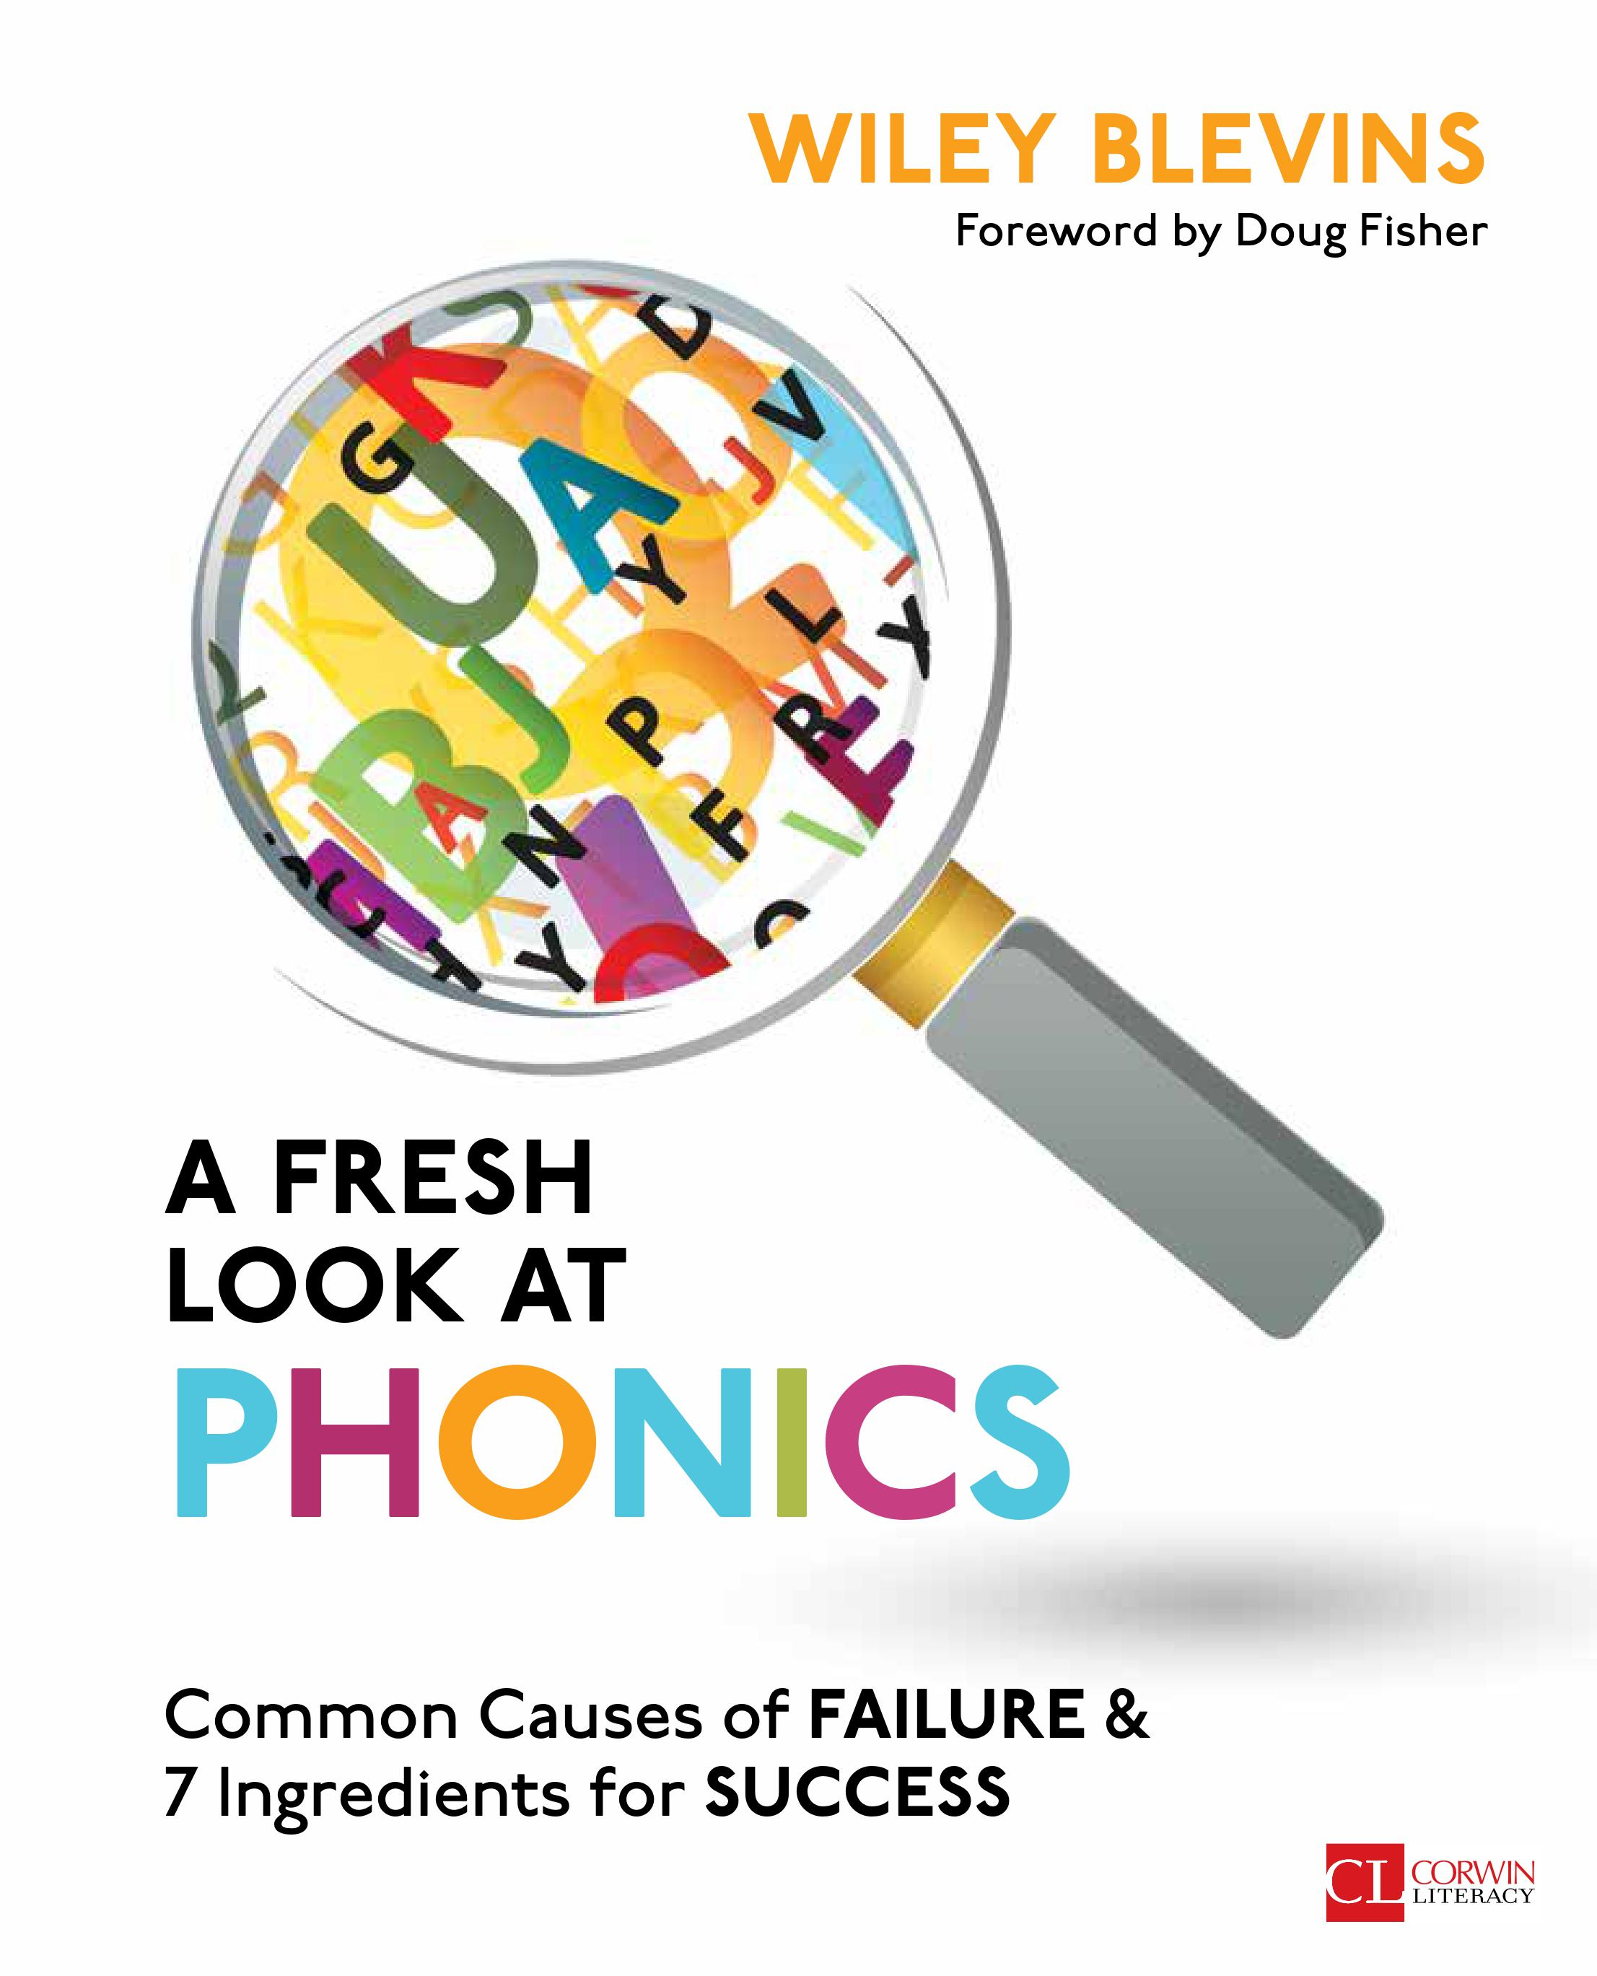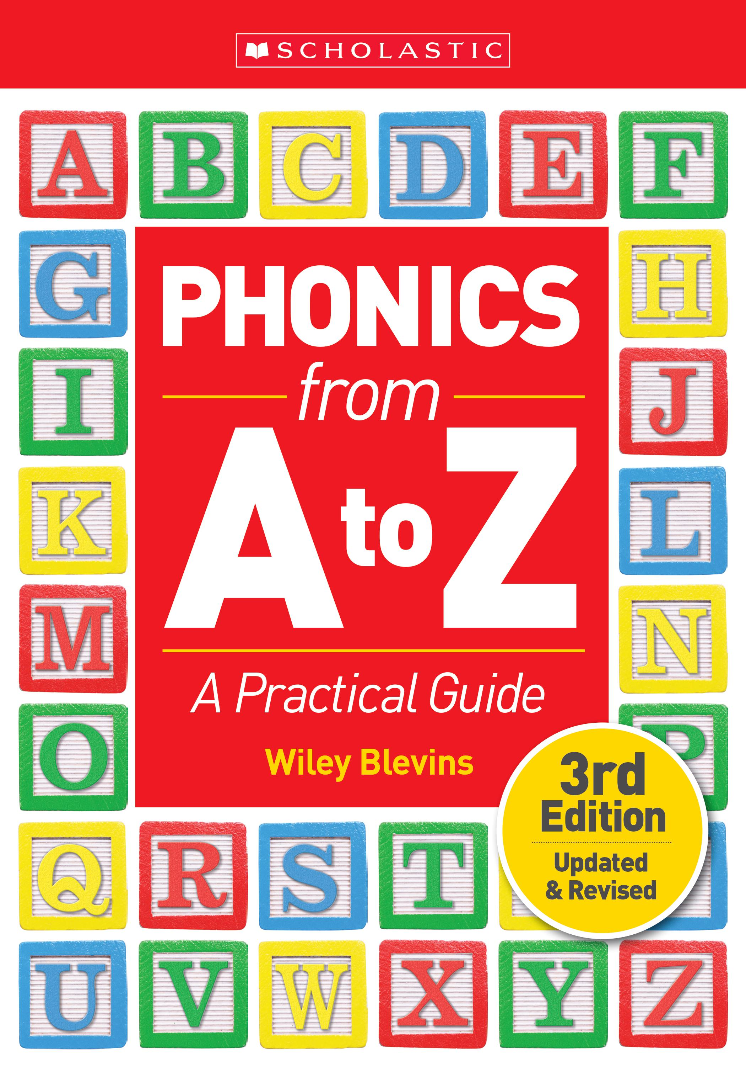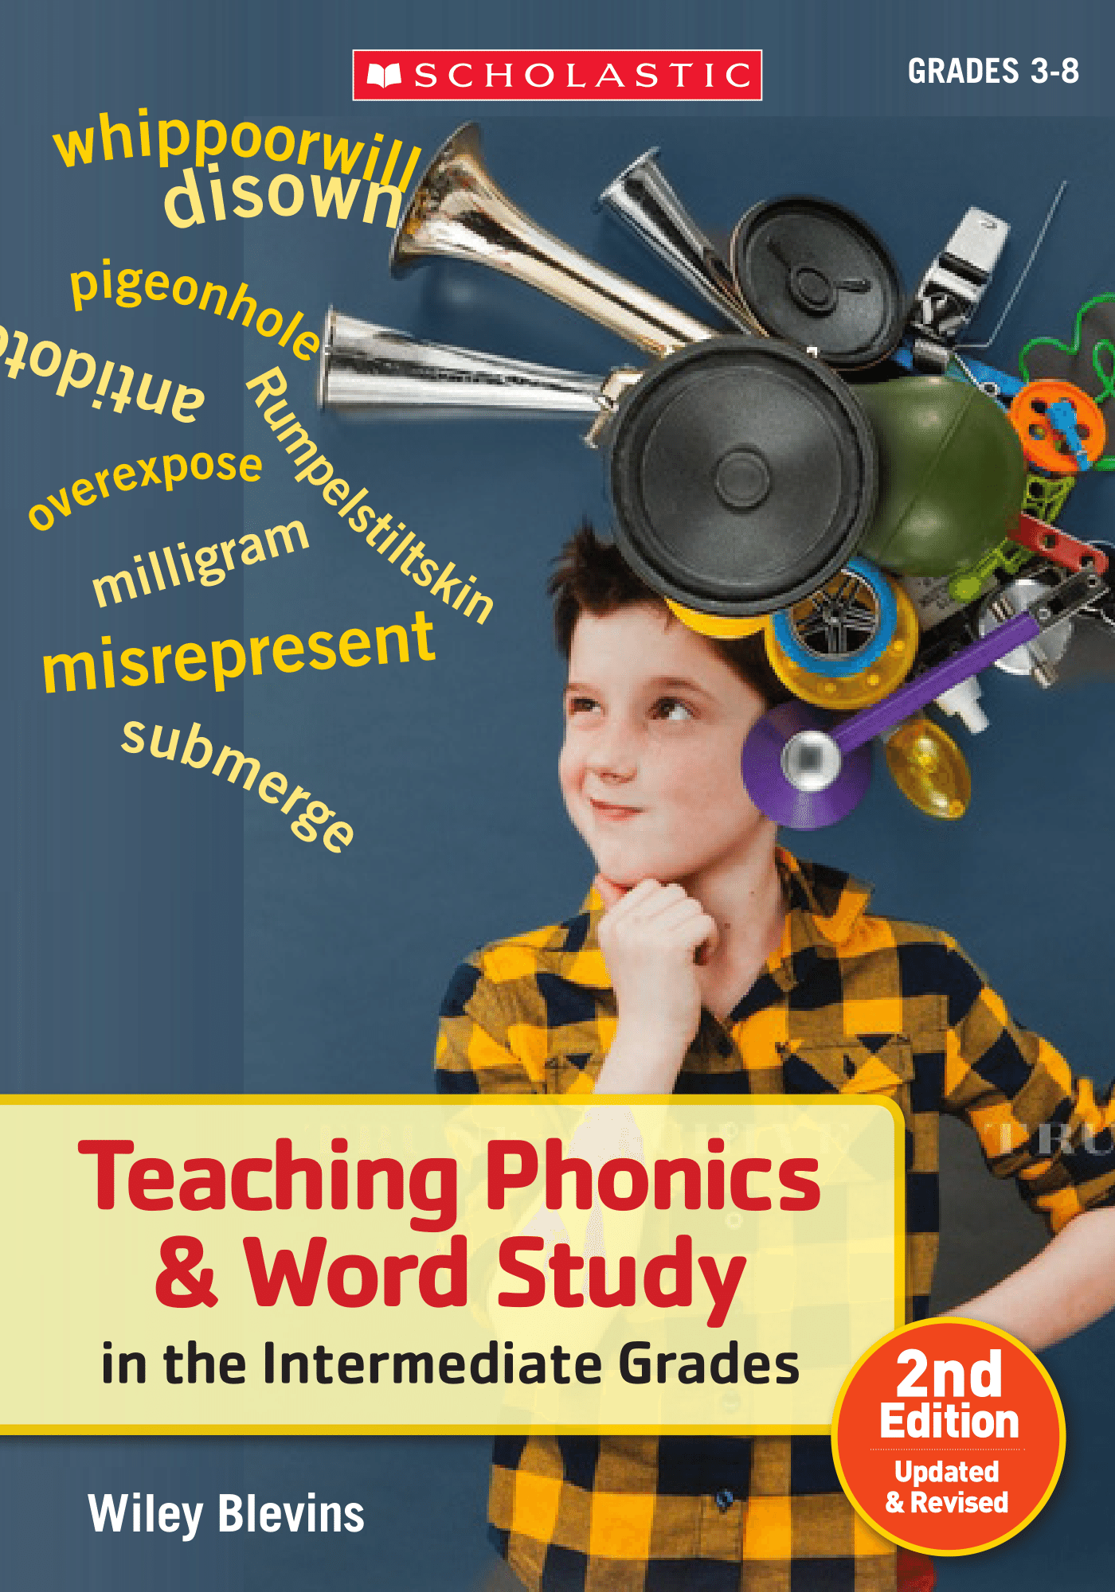

Wiley Blevins  wbny@aol.com  www.wileyblevins.com

